CREATE AND CONFIGURE IBM CLOUD SERVICES

|  |  |
| --- | --- |
| Date | 3 October 2022 |
| Team ID | PNT2022TMID52857 |
| Project Name | IoT Based Safety Gadget for Child Safety Monitoring & Notification |
| Maximum Marks |  |

**Creating node-red service**

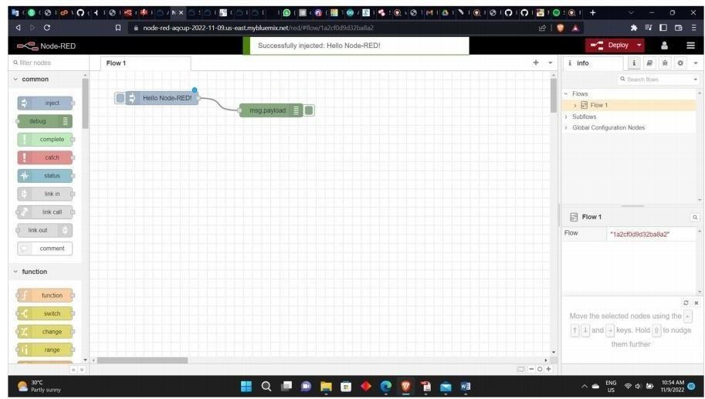

Creation of node red service

# Database in cloudant database

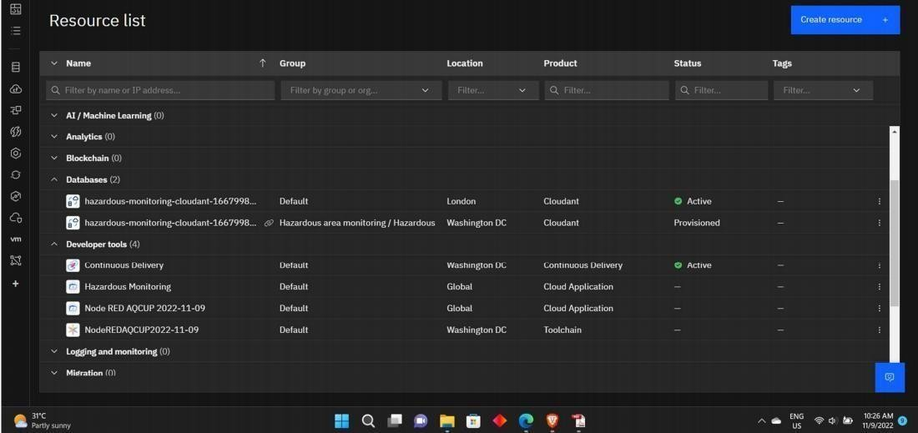

Creating a database in the cloudant DB

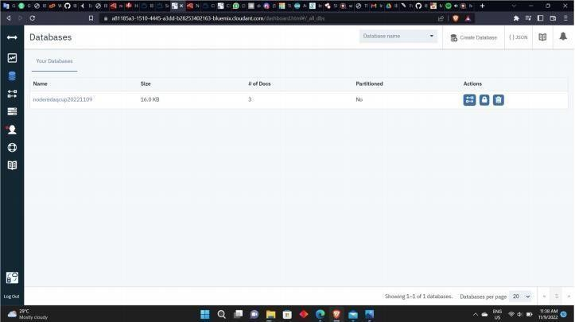

Created database 2

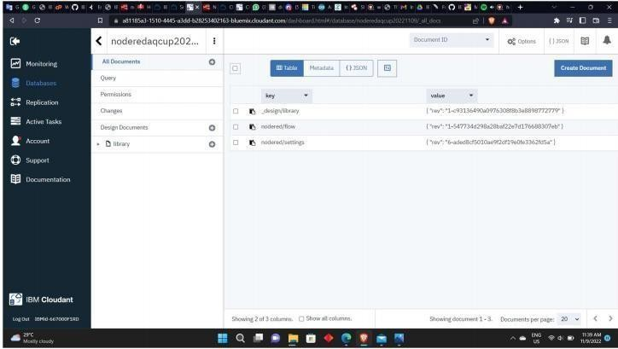

IBM cloudant

# IBM Watson IoT platform and device

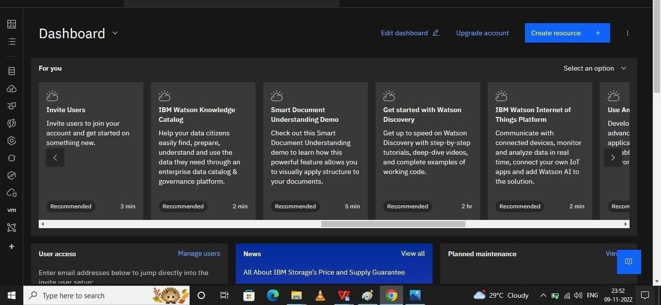

I

BM Watson Dashboard

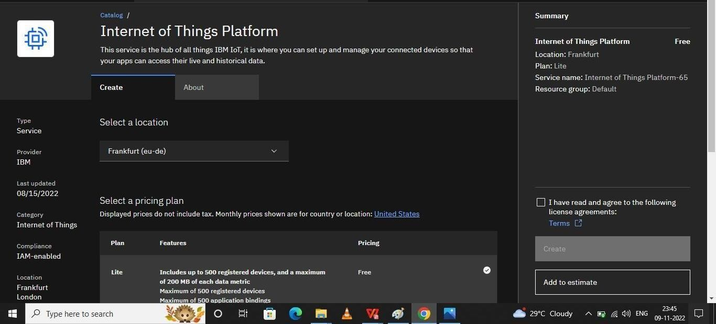

IoT catalogue in IBM Watson

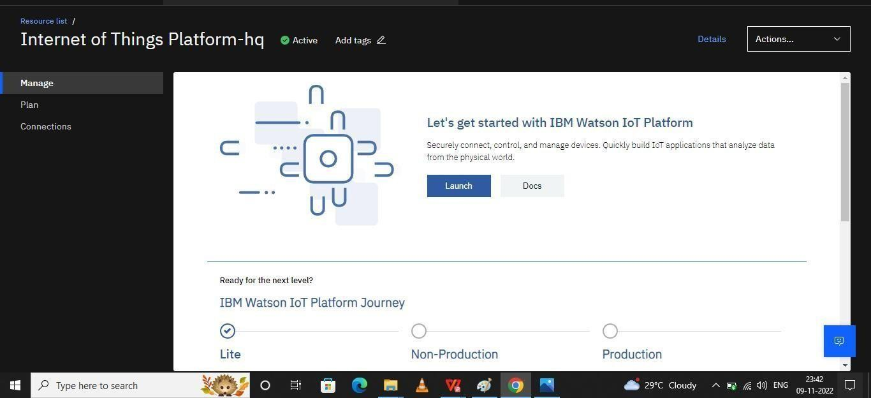

IOT platform in IBM cloud

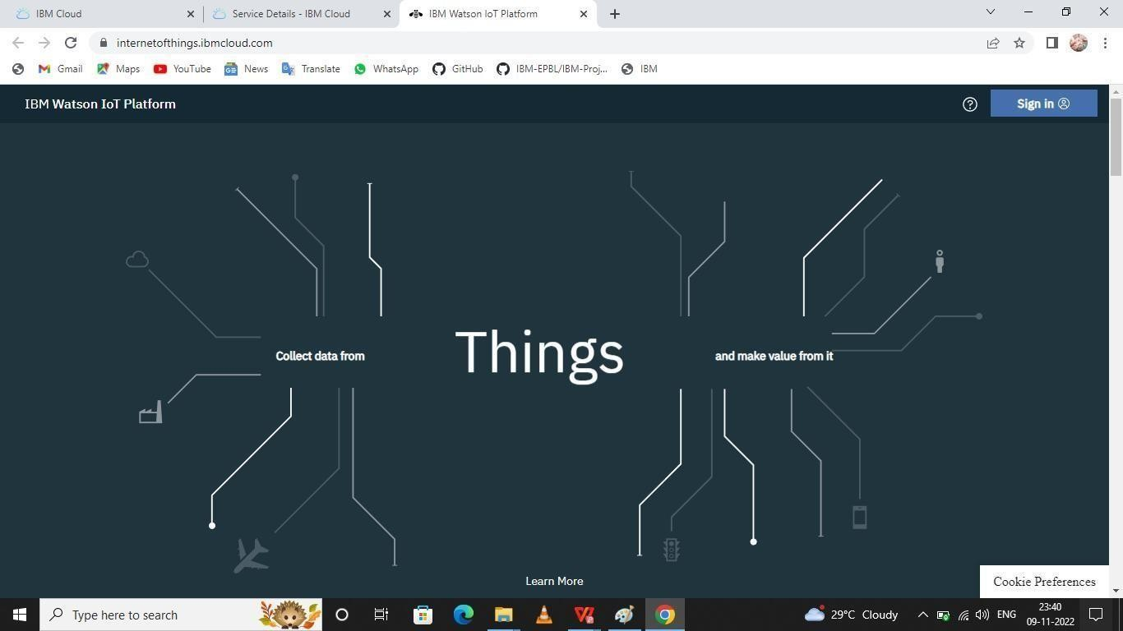

Module creation in IBM cloud

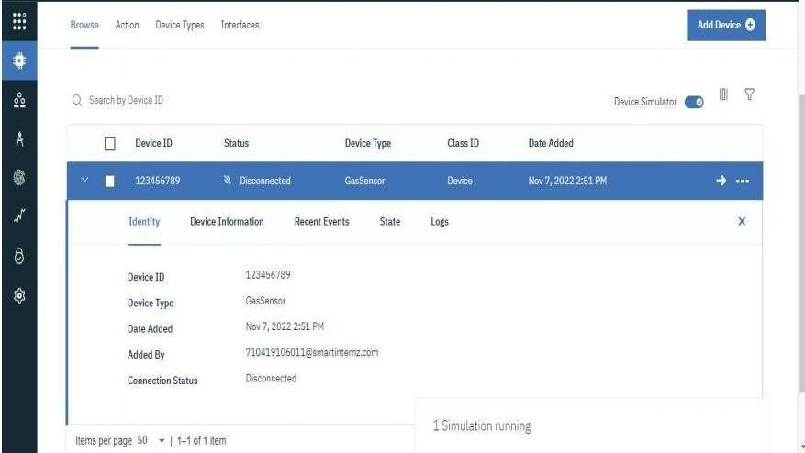

Adding modules and devices in the IBM cloud